Winterslow Men’s Shed
Following a meeting on a walking holiday by one of our shedders, contact was established with a committee member of Romsey Men’s Shed which led to an invitation to visit. So, we duly donned our tour outfits and along we trudged.
A warm welcome awaited and we were given the full treatment, including the story of how they came to be formed and how they operate within the greater umbrella of a community school community. A question and answer session followed (all with tea and coffee of course, together with the biscuits we had taken as a thank you present!) and then a tour of the workshop, covered outside workspace and social activity building.

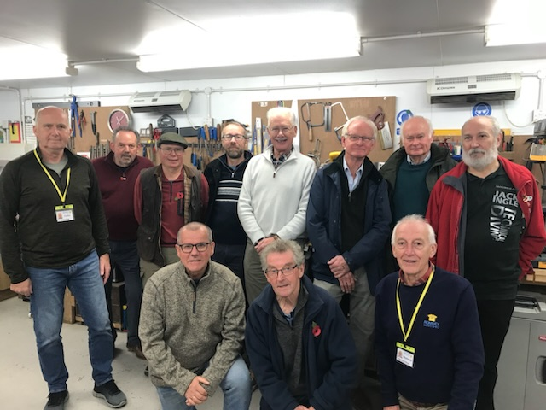
WINTERSLOW MEN’S SHED ON TOUR!
All in all, a very worthwhile visit which has prompted some interesting thoughts and conversation about what the future may hold for our own shed.
Back at our own shed, we are still busy working away on various projects and have completed and handed back a few recently! Please contact us by email at shed@winterslow.org.uk for more information if you are interested in what we do or have a project needing our attention.
The Shed meets on a Thursday morning from 9.30 to 12.00 in the Pavilion on the recreation ground (opposite the Primary School).
Geoff Freeth

‘Create, Converse, Connect’

